SQL Workbook

MIS 2100

# Data Dictionary

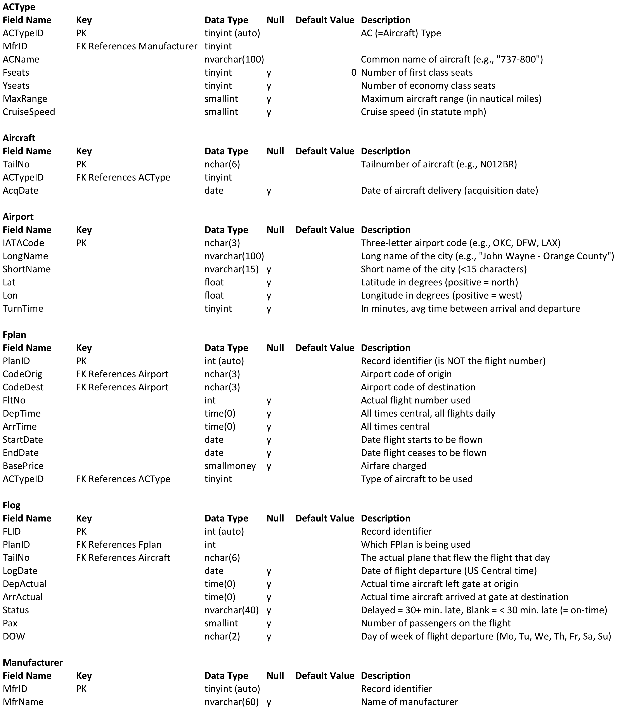

# ERD

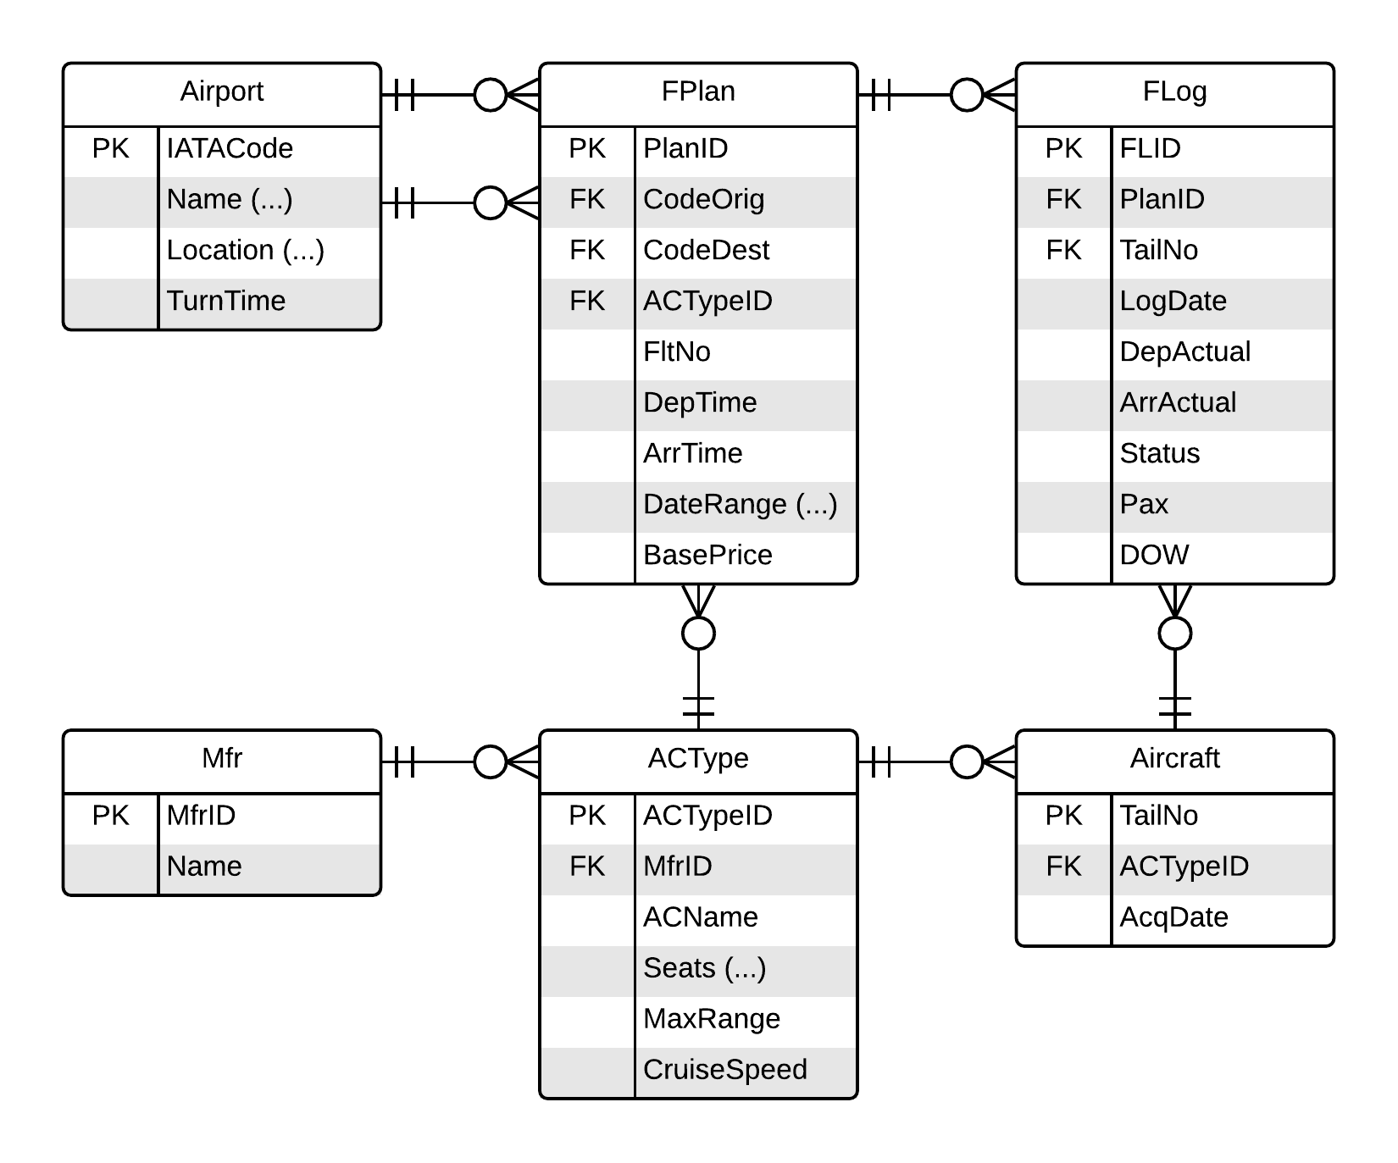

# Single-Table Queries

1. List all information about all the aircraft in the Aircraft table.
2. The airline is looking at adding a new route that is 1,586 statute miles in distance. Which aircraft types included in the database could handle a route of this distance? (Think about what columns you should include to help your boss understand that you’ve outputted the right info.)
3. Show every flight plan for which the base price is above $250. For each, show the origin code, destination code, flight number, departure time, and base price.
4. For every flight plan that originates in SAN, show the base price as well as what the base price would be if all flights originating in SAN had a 10% price hike. Name this new column something useful so that it’s clear what the output represents.
5. Which flights in June 2015 had 20 or fewer passengers on board? For each, show the date, PlanID, and number of passengers. Order results by date, then by origin code alphabetically.
6. Show the name (use ShortName) of every airport located above 40° latitude and order the results from north to south. (Think about what columns you should include to help your boss understand that you’ve outputted the right info.)
7. Retrieve those airports that are the three most northern.
8. Show the city pairs (i.e., CodeOrig and CodeDest) that are among the 10% most expensive. Output each pair+price only once.
9. For each logged flight *not* marked “delayed” or “canceled”, give the PlanID, the date of the flight, how many passengers were on the flight, and the duration of the flight. (*Hint: use DATEDIFF to find the duration of the flight.)*
10. Show the average price for all flights listed in the FPlan table.
11. Show the average price for all flights listed in the FPlan table grouped by origin code.
12. Show the average price for all flights listed in the FPlan table grouped by origin code and including only those origins where the average price is above $175.
13. Show the average duration for all flights in the flight log.
14. Show all the airports that have the word “county” in their long name.
15. Show the flight plan information for all plans that originate in OAK, SAN, SEA, or SNA.
16. Show the flight plan information for all plans that DO NOT originate in OKC, AUS, TUL, or XNA. The query should also ensure that only flight plans that were current as of 1/1/16 are shown.
17. List all airports (use ShortName) that begin with the letter O.
18. List all flights that were marked as canceled during the first 10 days of June 2015.
19. How many passengers were transported on each day during in the second half of June 2015?
20. For each date in June 2015, how many flights were either delayed or canceled.
21. How many flights were NOT marked “Canceled” on each day during the second half of June 2015?
22. Which flight plan resulted in the greatest number of passengers flying in June 2015?
23. For each day of the week, show the total number of flights that were flown (and not canceled).

# More-Advanced Queries

1. Output all columns from the FLog and FPlan tables, joining them together where there’s a primary key equal to the foreign key.
2. For each aircraft used by the company, show the tail number, the acquisition date, the name of the manufacturer, the type name (ACName), the number of coach seats (YSeats), and its cruising speed. Order results by tail number (lowest to highest).
3. Output each type of aircraft in the database as well as the number of aircraft of each type owned by the airline.
4. For each day of the month in June 2015, show how much revenue was generated (assuming everyone paid the base price).
5. Give the tailnumber, manufacturer, and aircraft name of all aircraft that departed an airport with a turnaround time of under 40 minutes. Make sure that no aircraft (tailnumber) is shown more than once in the output.
6. Retrieve the ShortNames for both the origin and destination airports where the base price for the planned flight is over $300. *Hint: You’ll need to include the Airport table TWICE in your FROM clause, once to represent origin airports and once to represent destination airports.*
7. Which flights that departed on Tuesdays in the first half of June 2015 were full? For each full flight, list the date, flight number, IATA codes for origin and destination, and the number of passengers on board. Order results by date and then alphabetically by origin code.
8. Find the logged flights on June 15, 2015 that were under 60% full. For each, show the origin, destination, flight number, number of passengers, aircraft type name, and the load factor (%age full).
9. What flights departed San Diego between 6/1/15 and 6/7/15 (inclusive)? For each, show the date, the flight number, the origin and destination (use ShortName), the scheduled departure time, and the actual departure time. Order results by flight date, then by time. (Use ShortName in your query to find the flights departing San Diego.)
10. Which 10 logged flights generated the most revenue for the airline (assuming everyone paid the base price)? For each, show the date, flight number, origin, destination, passenger count, and total revenue.
11. Output all aircraft types that are in the database and, for each type where the company owns one, show all the tail numbers of that type. (*Hint: may require a sub-query.)*
12. Output the average duration of all flights flown in June 2015 for each aircraft used by the airline.
13. What routes was the aircraft with tail number N112BR scheduled to fly on June 12, 2015? For each route scheduled, include the relevant flight number, departure city name (ShortName), scheduled departure time, actual departure time, arrival city name (ShortName), scheduled arrival time, actual arrival time, and the status (FStatus) if any. Order results from earliest to latest departure.
14. In terms of lost revenue, which five flights were the company’s costliest cancellations? Be sure to include all information that your boss would deem relevant to this question.
15. Show the three origin-destination pairs with the highest number of cancellations. Use the ShortName for both origin and destination.
16. Show the origin-destination city pairs that have had flights delayed (as shown in the database). For each, output how many times a flight was delayed as well as the average length of the delay (in minutes). Order the output by the average delay (in minutes), then by the number of delays.
17. Create a “departures board” that shows all morning flights scheduled to depart from Oklahoma City on August 26, 2015 (note: this is about *scheduled* departures, not *actual* departures). The output should include, for each OKC departure, only the following: the flight number, the destination name (use ShortName), the scheduled time of departure, and the aircraft type used (use ACName). Results should be ordered from earliest to latest.

# Bonus Problems

1. Which aircraft departed Oklahoma City three or more times on June 19, 2015? For each, give the tailnumber as well as the number of departures (from Oklahoma City) and total number of departures for the day.
2. Of those aircraft that either departed from or arrived in Austin during June 2015, give the total number of delay minutes for all landings in the month.
3. Give the tailnumber and acquisition date of the aircraft that visited the most locations in June 2015.
4. Show those origin-destination airport pairs for which the base price is higher than the average of all flights from that origin (e.g., if the average base price for all flights leaving SLC is $400, find all SLC-xxx city pairs where the base price is over $400).
5. For each planned flight, list the (ShortName) origin and destination, the base price, the average price of all flights from the given origin, and the difference between the base price and the average price. Order the output alphabetically by origin.
6. Show all flights scheduled for August 15, 2015 that generated over $10,000 on June 15, 2015